**PeopleSoft Inventory - Setups and Transactions**

Contents

1. Setting up Order Fulfillment 3

2. Creating a Fulfillment Transaction 6

3. Setting Up Material Replenishments. 15

4. Pegging in PeopleSoft Inventory 23

5. Returned Material Authorizations 29

6. Par Location Replenishments 33

# Setting up Order Fulfillment

Business Unit Level Fulfillment Options

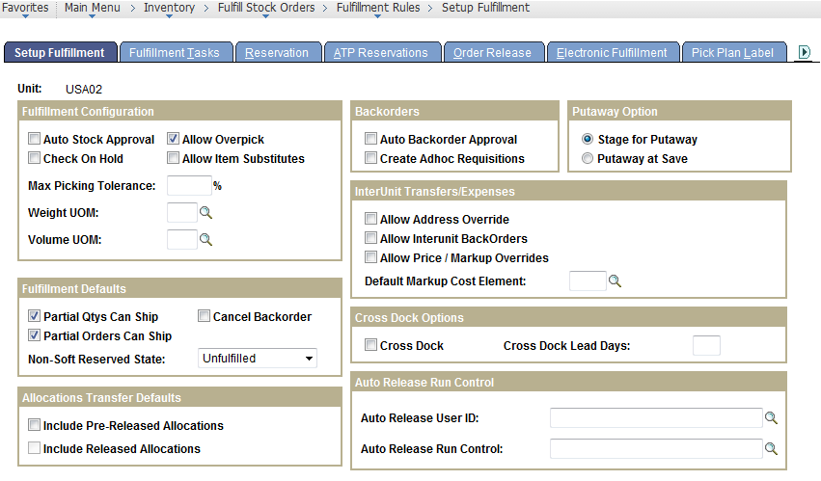

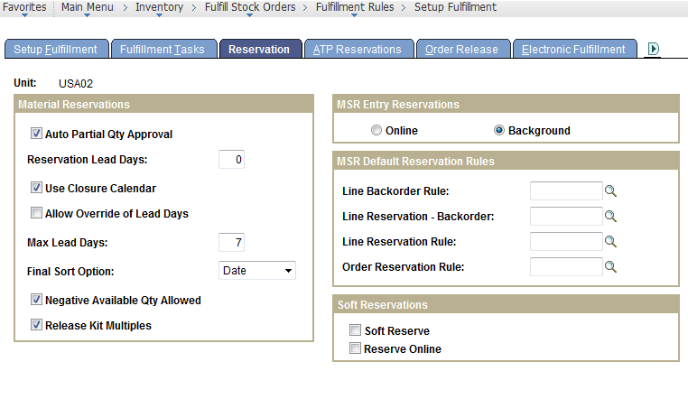

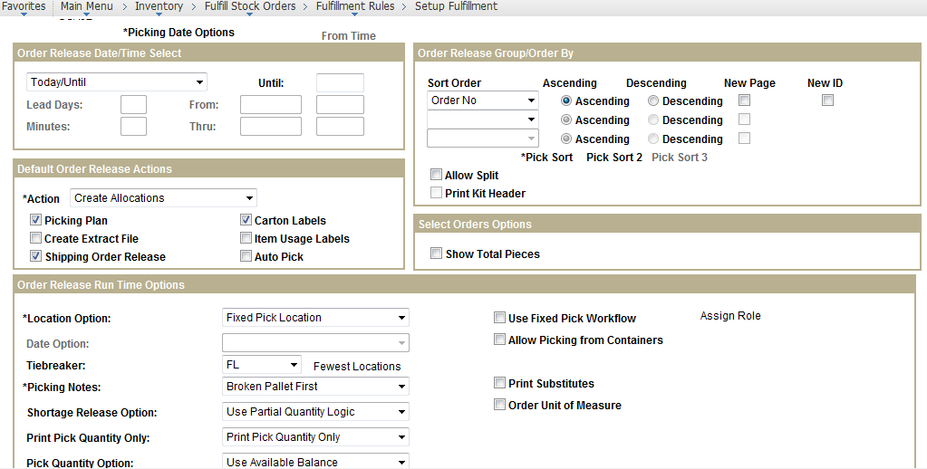

Business Unit Item Level Fulfillment Options

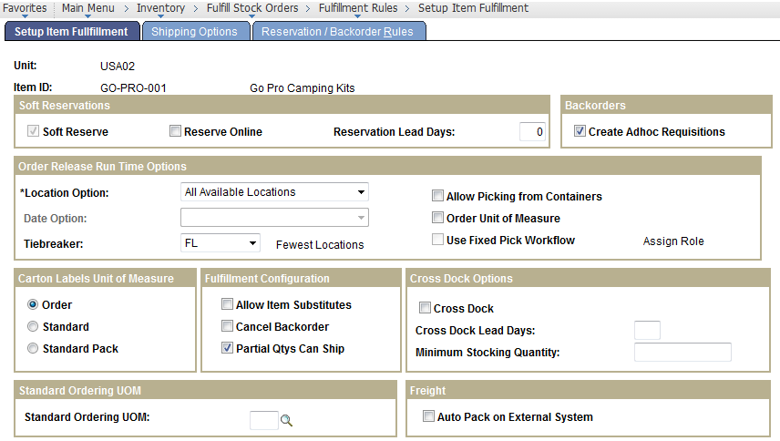

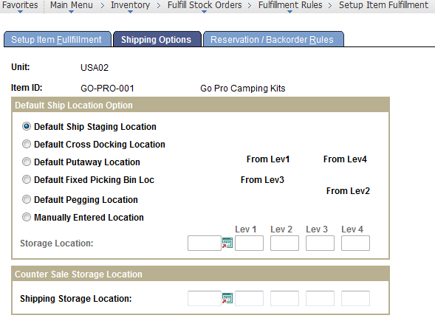

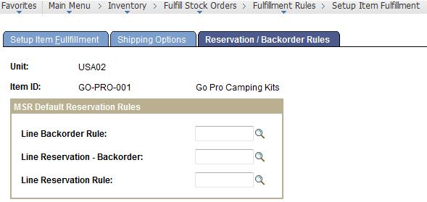

# Creating a Fulfillment Transaction

Create a Customer Order:

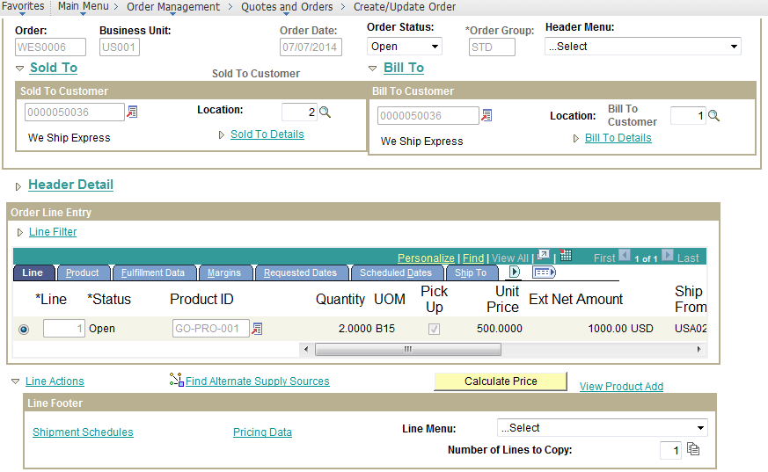

Under the Shipment Schedule, Mention the Inventory Business Unit from where to Pickup the Material to fulfill the order.

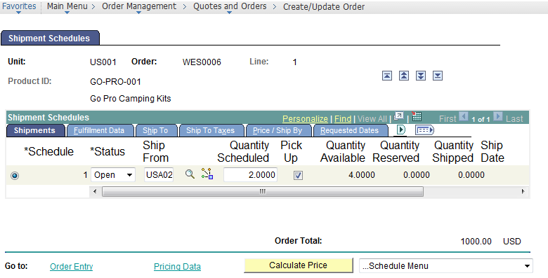

This Creates a Stock Order to the Inventory Business Unit. Approve the Order.

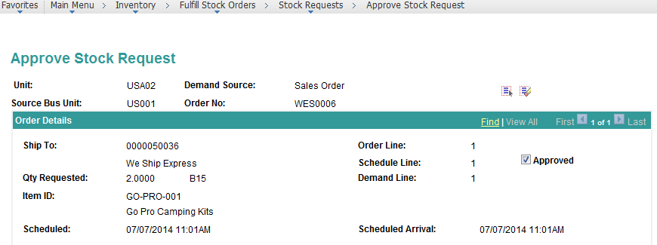

Run the Material Reservation Process.

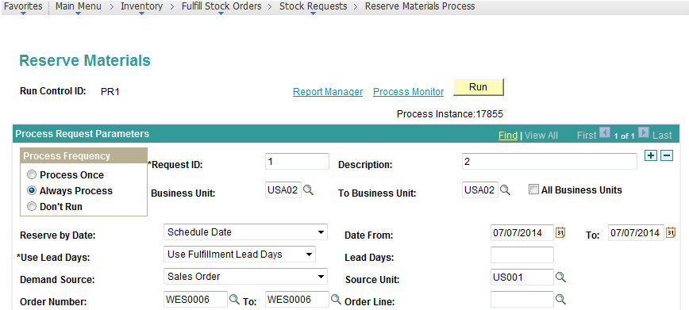

Adds a Reservation against the material available quantity.

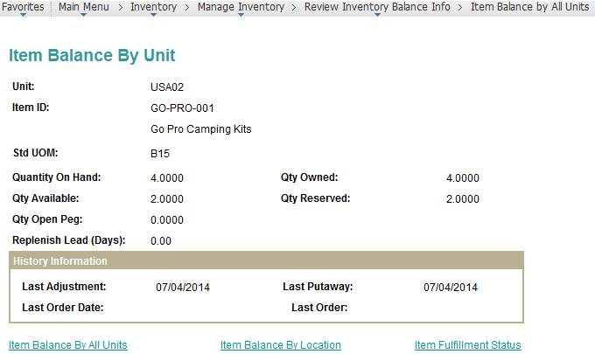

Run the Order Release Request Process.

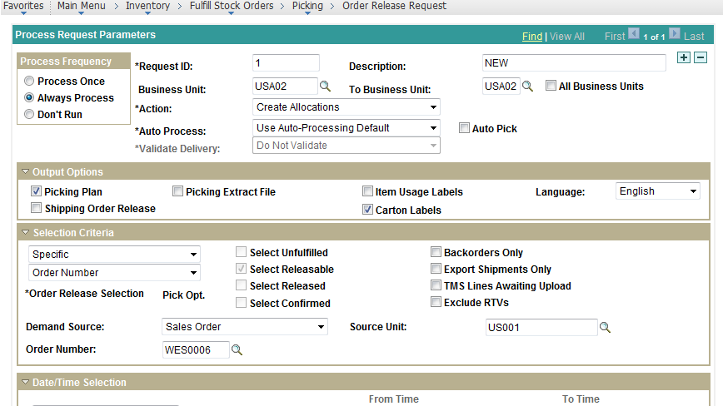

Material Pick-up Plan Generated.

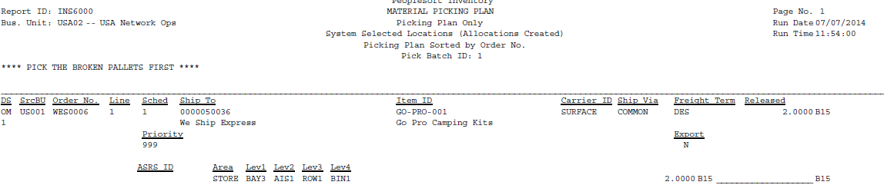

Confirm Material Pickups.

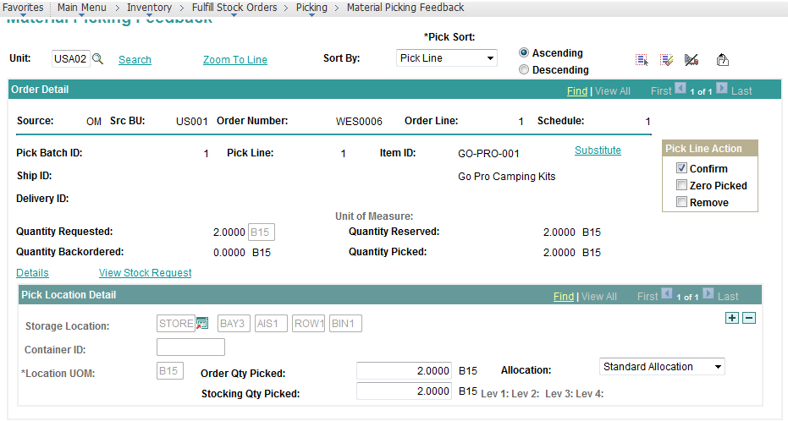

Run Picking Confirmation Process.

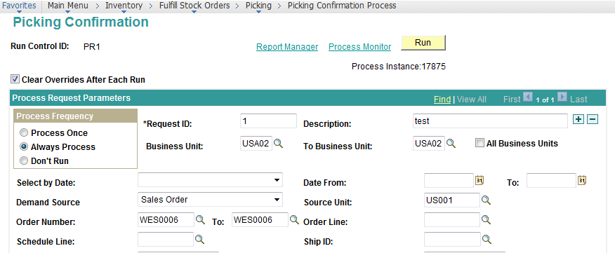

Run Material Shipping process.

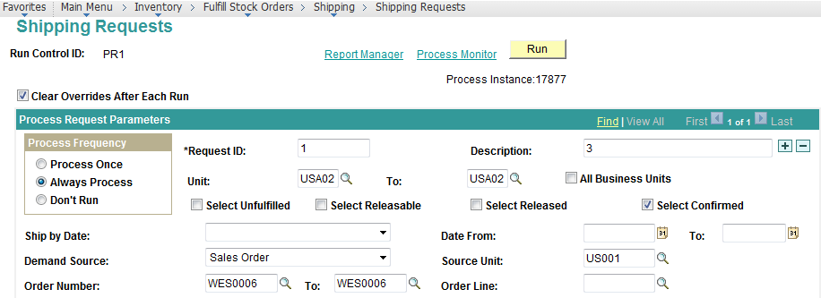

Generates the material Shipping ID.

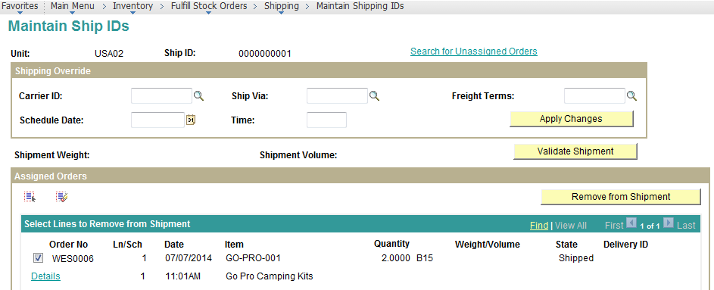

Run the Material Packing Slip Print Process:

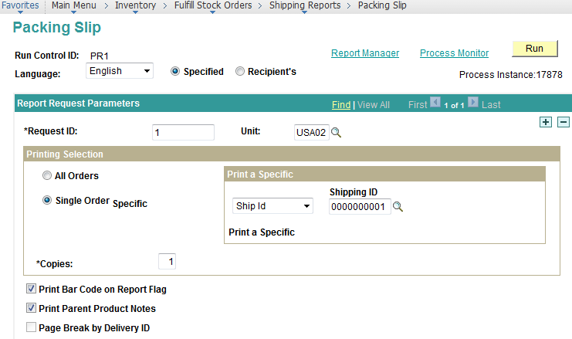

Generates the Material Packing Slip:

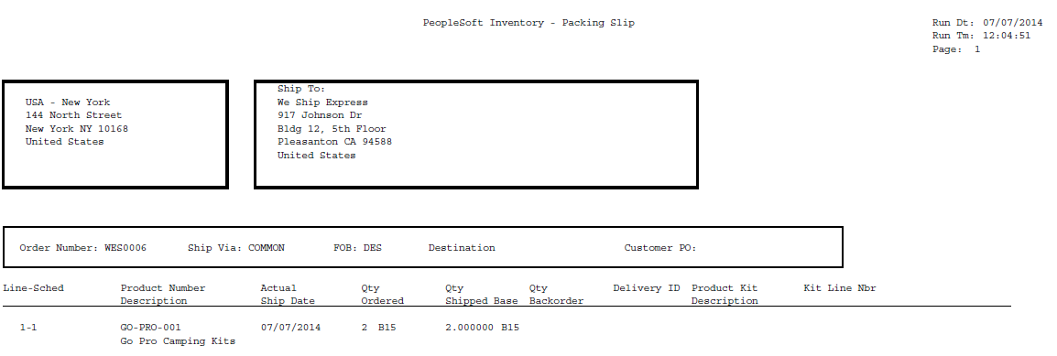

Deplete the on-hand Quantity using the delivered process.

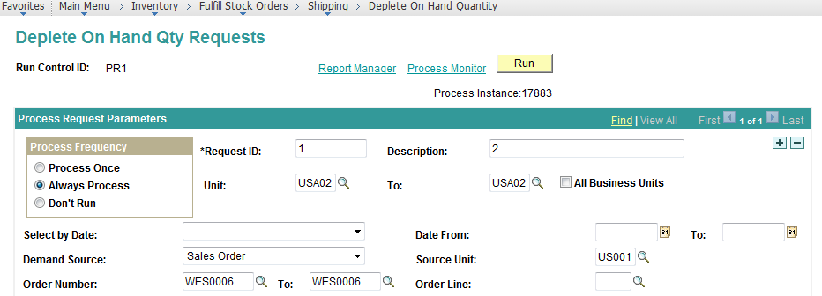

The On-Hand Quantity for the Material Gets Updated.

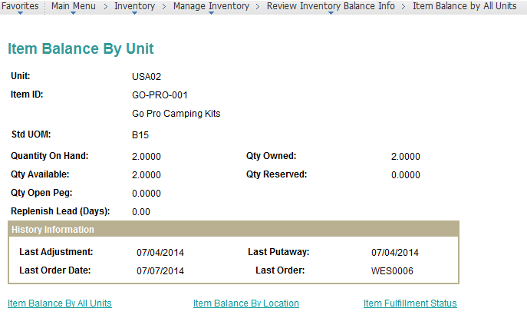

Use the Review Fulfillment Status Page.

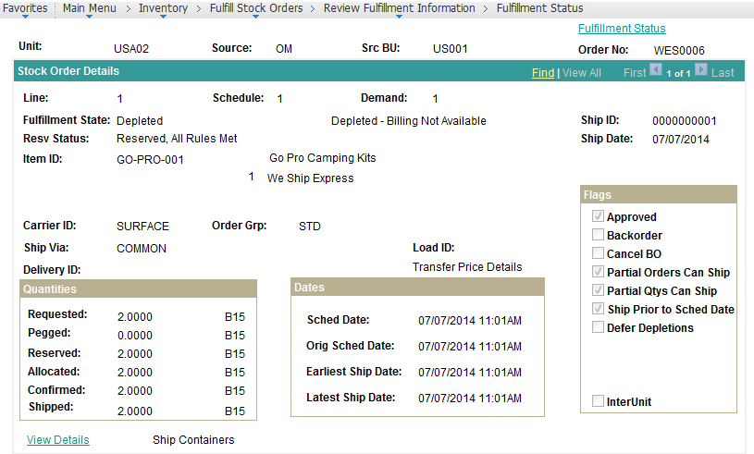

# Setting Up Material Replenishments.

Setup Material Replenishment Classifications:

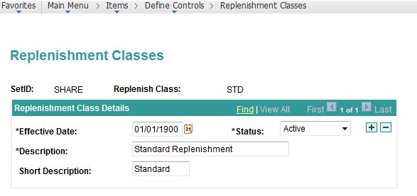

Material Stock-in Probability.

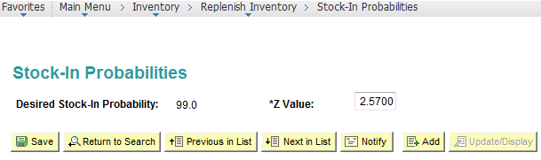

Setup Business Unit Replenishment Defaults.

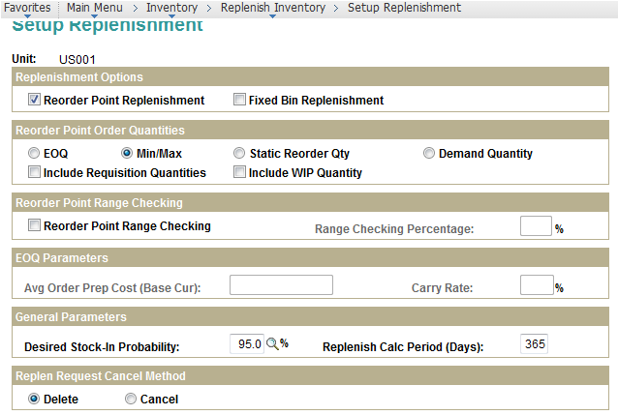

Setup BU- Material Replenishments.

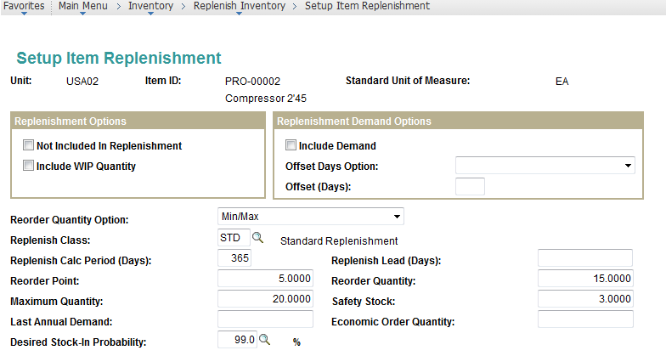

Running the Calculate Replenishments Parameters Process – only if you have sufficient past data in the PeopleSoft System to calculate past annual demand/ demand variances.

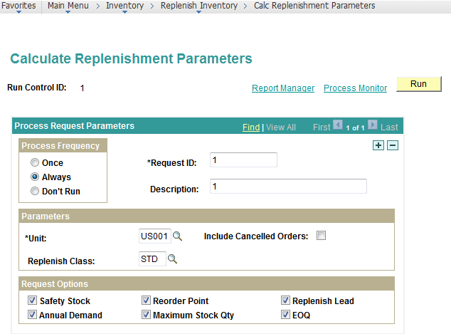

**Some Typical Calculations that run during this Process:**

* Replenishment Calculation Period = Period for which the past data is studied. Specified on BU/ Item Setup.
* Annual Demand = Total Demand Not in Unfulfilled/ Cancelled Status during the Replenishment Calculation Period.
* Average Daily Demand = Annual Demand/ Replenishment Calculation Period
* Replenishment Lead = Average of Inventory Putaway Date – Purchase Order Issue date for the Material for all Inventory Putaway transactions during the replenishment calculation period.
* Demand Variance = Daily Demand Variance during the replenishment calculation period
* Standard Deviation = SQRT(Demand Variance)
* Safety Stock = Replenishment Lead Days * Standard Deviation * Z Score Value
* Reorder Point = Average Daily Demand * Replenishment Lead Days + Safety Stock
* Economic Order Quantity = SQRT(2*Annual Demand* Order Preparation Cost Specified on BU/ (Material Cost* Carry Rate Specified on BU))
* Maximum Stock Quantity = Average Daily Demand *(Replenishment Lead Days+ Replenishment Calculation Period) + Safety Stock

Setup Requisition Loader Defaults.

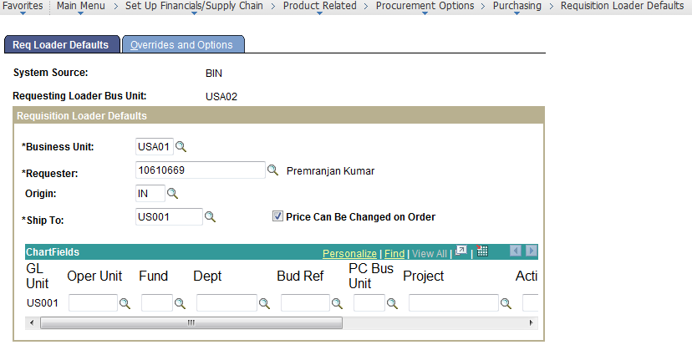

The Material Availability status has fallen below the Re-order point threshold.

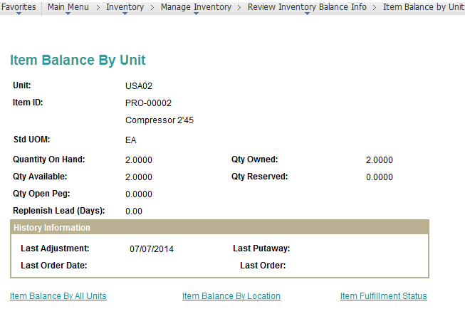

Run the Create Replenishments Process.

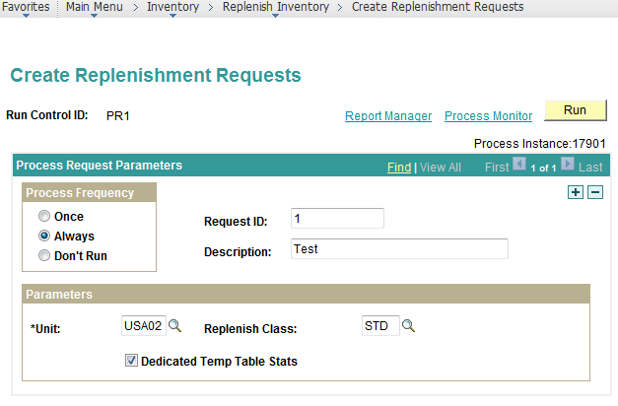

This process calculates the demand and creates a replenishment request for the material.

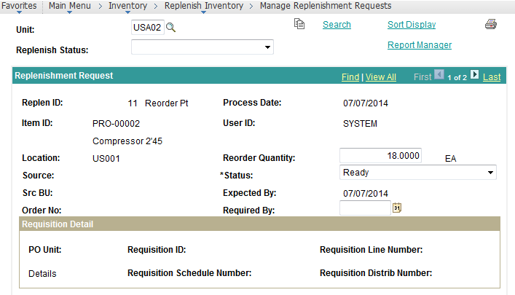

Run the Requisition Loader Process in Purchasing:

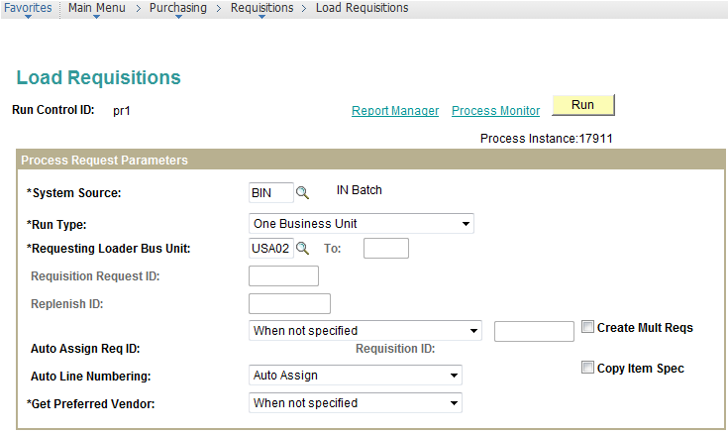

Message log generated on process completion:

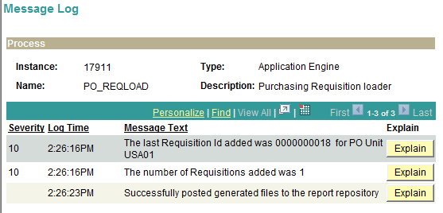

Review the Requisition generated: Source to Inventory is Unchecked so that a Purchase order is created for the material and not an Inventory Material demand.

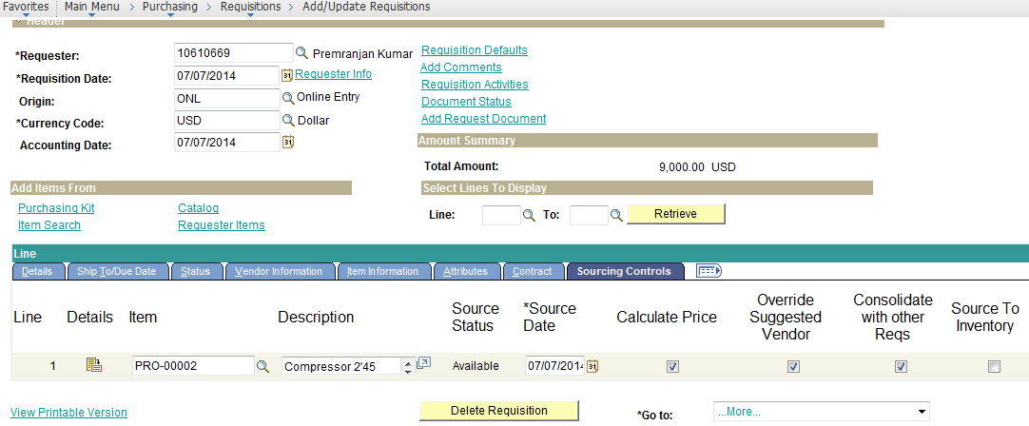

Inventory Replenishment transaction is now in Processed Status:

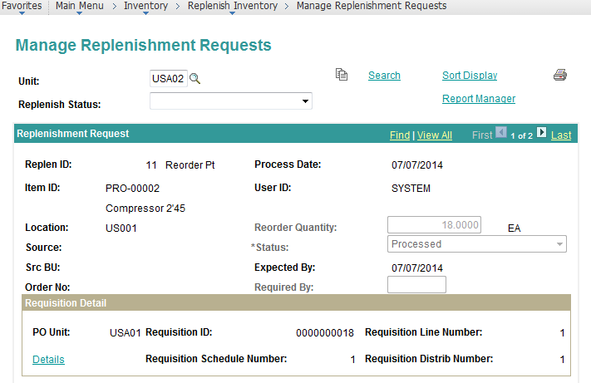

# Pegging in PeopleSoft Inventory

Setup Business Unit for Pegging.

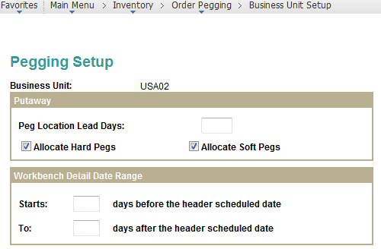

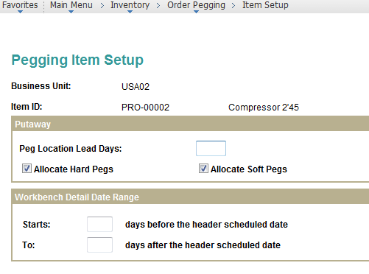

Supply Line Created:

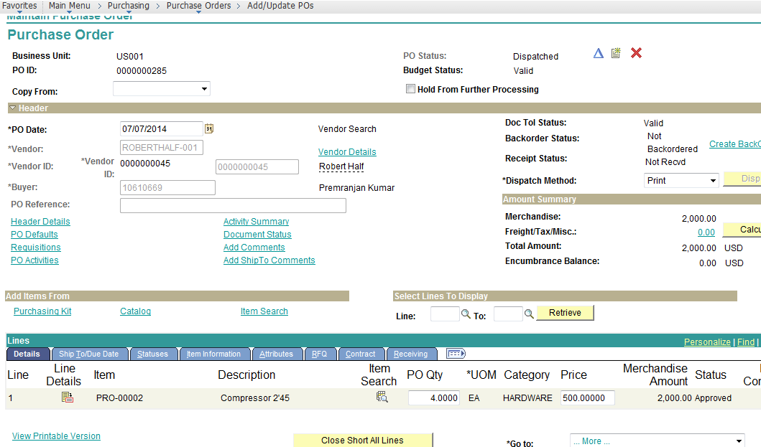

Demand Line Created.

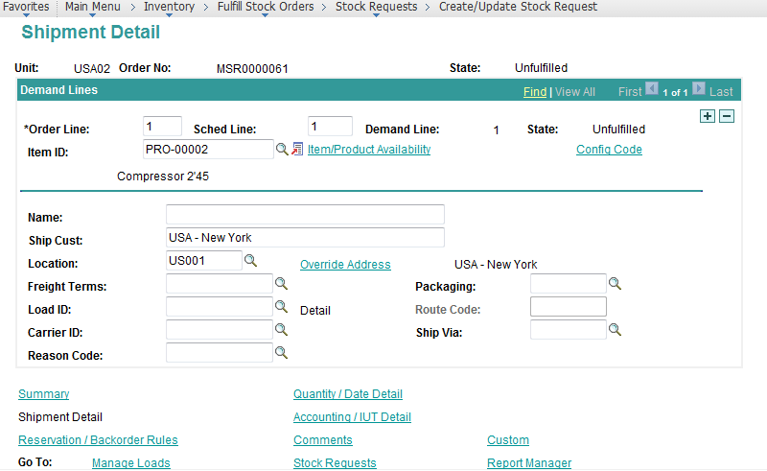

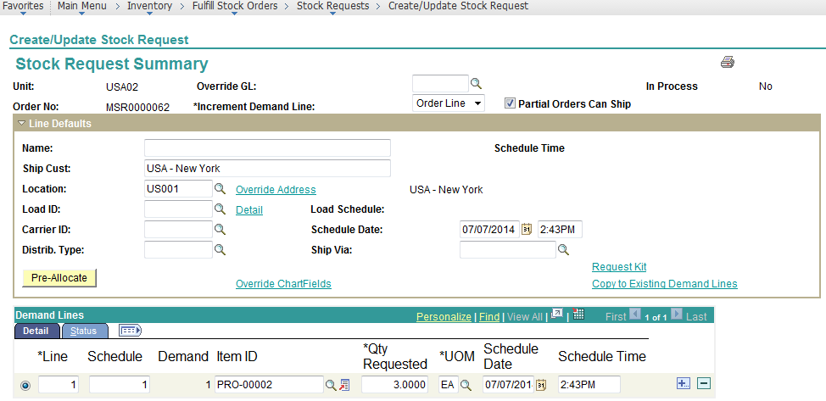

Approve the MSR.

Create a material Peg for the Demand.

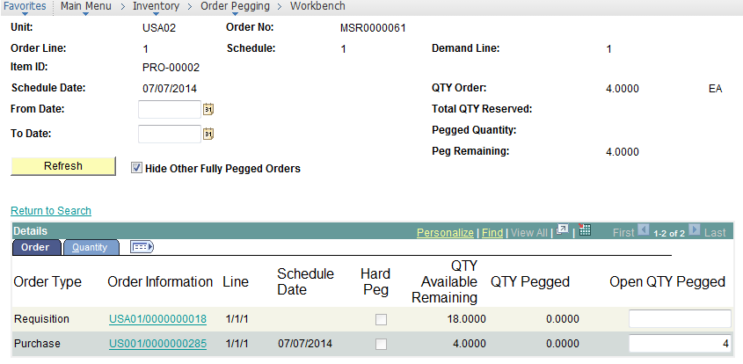

The Supply Quantity arrives for the material.

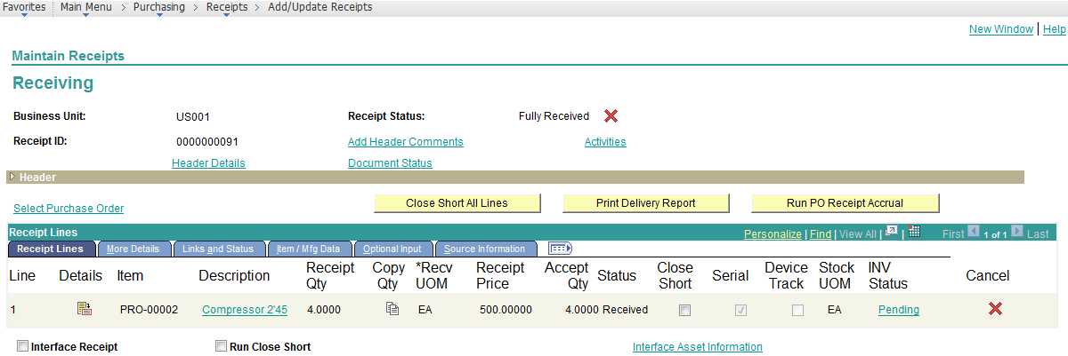

When the material is Putaway for the Inventory Business Unit, the material is auto-reserved.

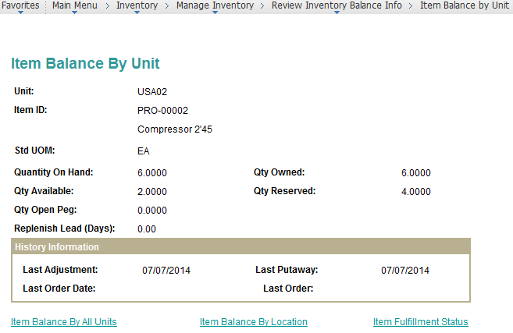

Navigate to the Pegging Enquiry Page.

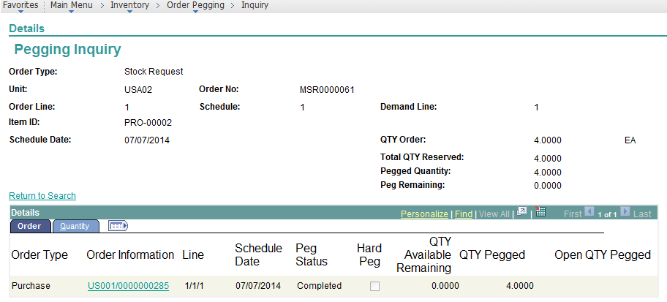

The Normal Stock issue process flows now.

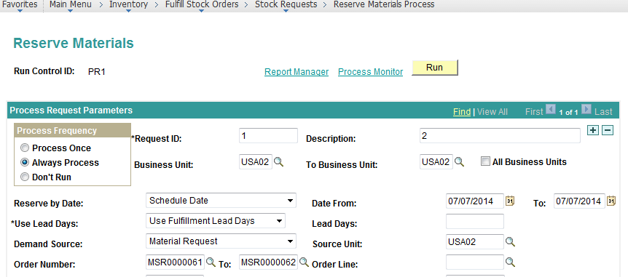

The Reserve Materials Process logs an Exception for the Unpegged Demand (Since the material is in Short Supply):

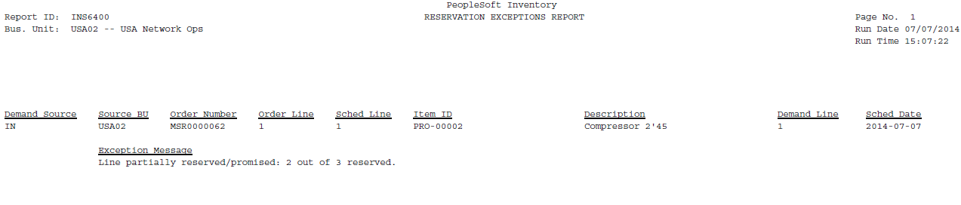

# Returned Material Authorizations

Create an RMA Document.

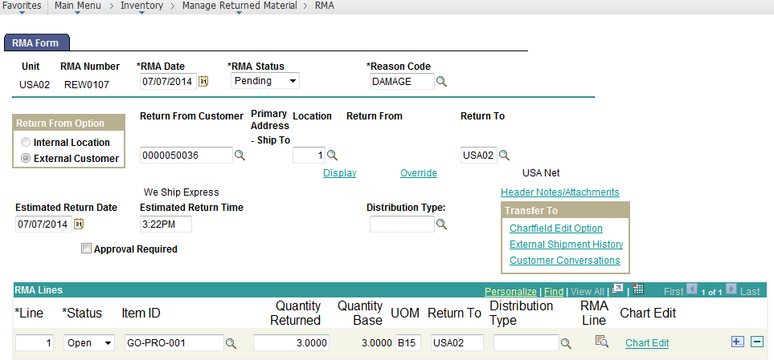

Add RMA Receipt Document.

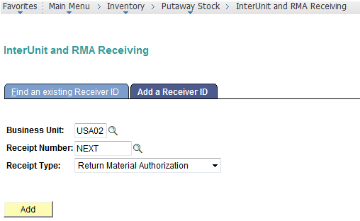

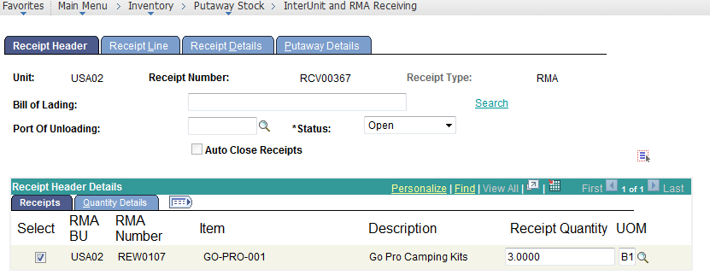

Run the Normal Putaway Processing

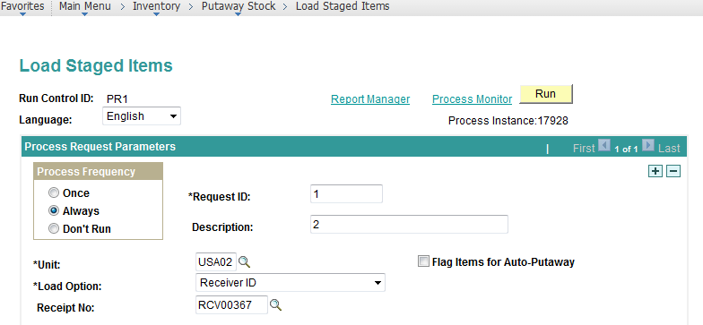

Provide the Stockroom Feedback.

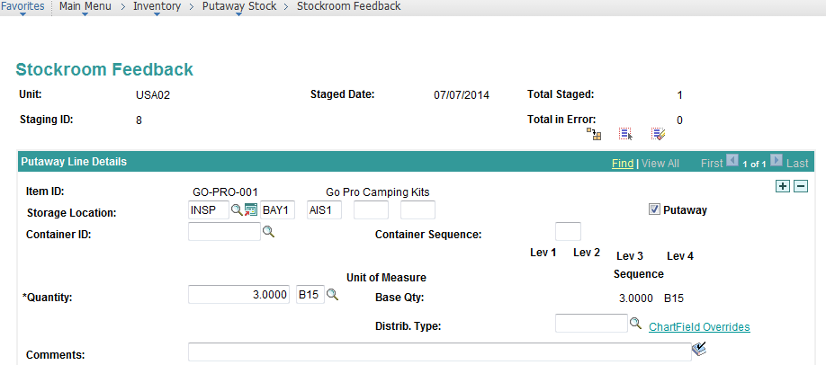

Complete Putaway:

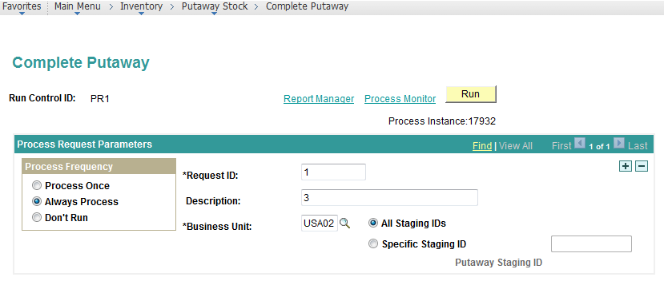

Increments the Material Available Quantity.

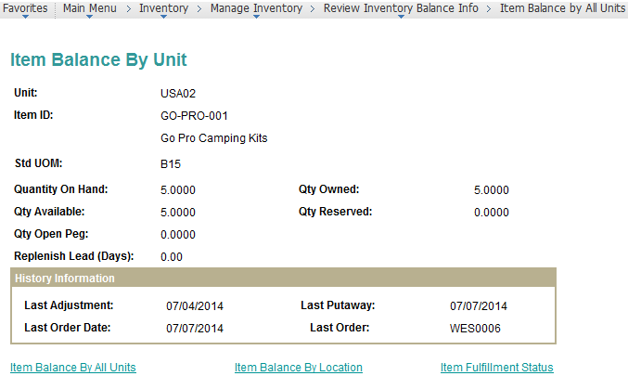

# Par Location Replenishments

Define Par group

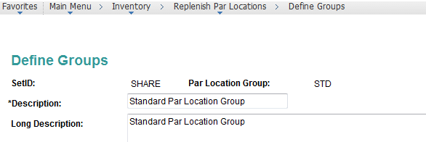

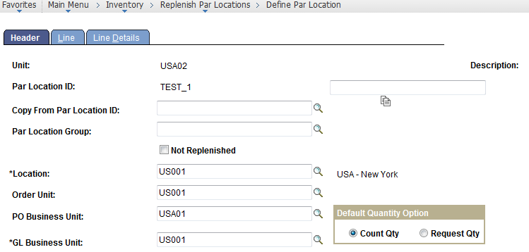

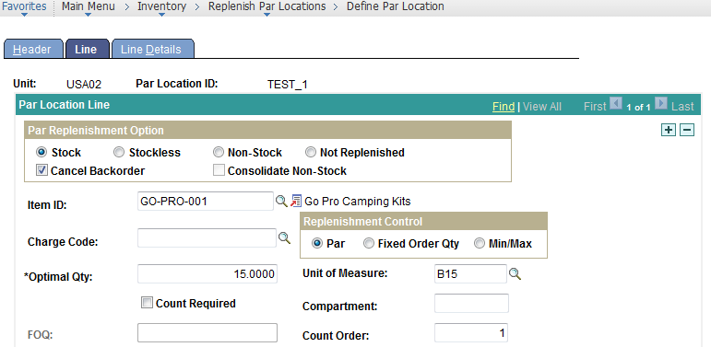

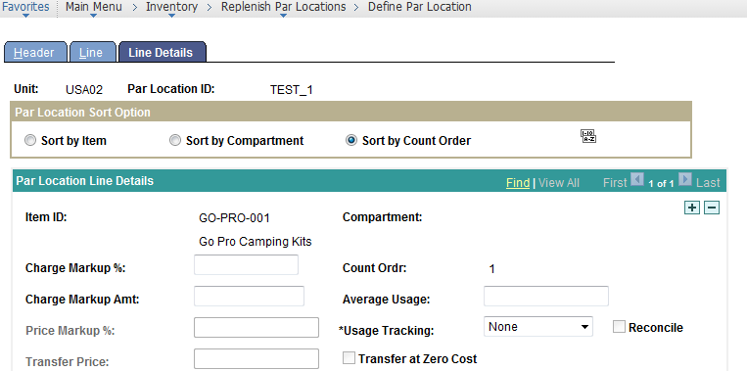

Create Par Location Item Count

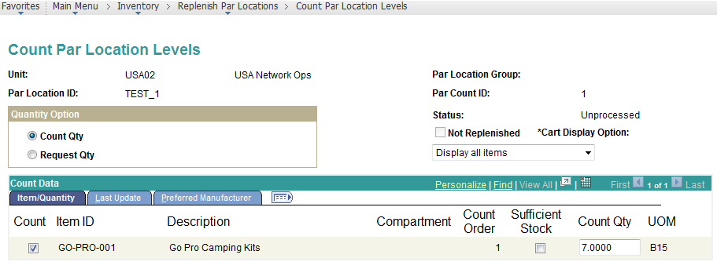

Run Par Location Replenishments Process

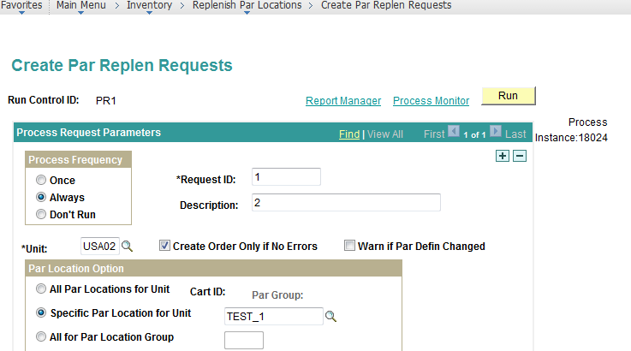

Creates an MSR for the Material:

